Project Design Phase-II
Technology Stack (Architecture & Stack)

Date | 19-02-2026
Team ID | LTVIP2026TMIDS66321
Project Name | Cafeteria Menu Display
Maximum Marks | 4 Marks

Technical Architecture:
To provide a dynamic, real-time digital display of menu items, pricing, and availability for cafeteria patrons.
Example: real-time menu updates and automated scheduling for breakfast, lunch and dinner transitions.
Reference: https://developer.ibm.com/patterns/ai-powered-backend-system-for-order-processing-during-pandemics/
Guidelines:
- map out the logic for CMS, menu item scheduling and real-time pricing updates.
- Media players connected to physical LED/LCD displays in cafeteria.
- A cloud-based backend or CMS for remate menu management and content hosting.
- Include APIs for POS integration to automatically sync prices or hide sold-out items.
- Identify storage for high-resolution food imagery, menu databases and digital assets in a Content Delivery Network.
- If applicable, indicate interfaces for recommendation engines that suggest daily specials based on the popular trends or inventory levels.
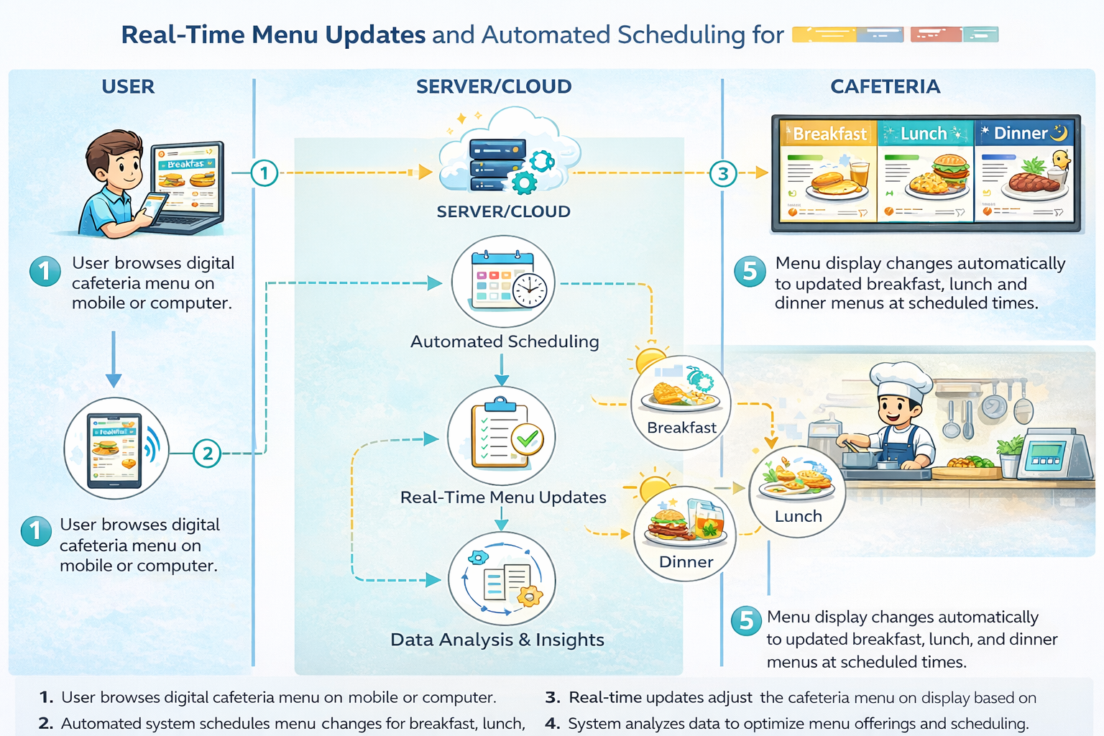
Table-1 : Components & Technologies:
S.No | Component | Description | Technology
 | User Interface | Digital signage display for customers and a dashboard for cafeteria staff to update menus. | HTML, CSS3, React Js/Vue Js etc.
 | Application Logic-1 | Core logic for menu management, price updates, and scheduling | Node Js/ Python
 | Application Logic-2 | Real-time synchronization service to ensure all display screens update instantly when a change is made. | WebSockets/Socket.io
 | Application Logic-3 | Image processing service to optimize and display food item photos on the menu. | Cloudinary API/Sharp
 | Database | Stores menu items, descriptions, prices, nutritional info, and availability status. | PostgreSQL/MongoDB
 | Cloud Database | Remote backup and synchronization for multi-location cafeteria management. | Firebase real-time database/AWS DB
 | File Storage | Storage for high-quality food images and promotional videos shown on the displays. | AWS S3/ Google Cloud Storage
 | External API-1 | Integration with a payment gateway if the display includes a QR code for self-checkout. | Stripe API/ Razorpay API
 | External API-2 | Weather or news API to display localized content alongside the menu to engage customers. | OpenWeatherMap API
 | Machine Learning Model | Recommendation engine to suggest “daily specials” based on historical sales data or time of day. | TensorFlow.js / Scikit-learn
 | Infrastructure (Server / Cloud) | Hosting for the backend API and the web-based display interface. | AWS EC2/ Heroku / Vercel

Table-2: Application Characteristics:
S.No | Characteristics | Description | Technology
 | Open-Source Frameworks | List the open-source frameworks used to build the responsive menu interface and backend. | Frontend: React.js or Vue.js with boot strap for responsive design.  Backend: Node.js or Django
 | Security Implementations | List all the security / access controls for menu management | Authentication: JWT or IAM for role-based access.  Network: Secure Wi-Fi with firewalls and HTTPS/TLS for data encryption.
 | Scalable Architecture | Justify the scalability for handling multiple display screens across different cafeteria sections. | 3-Tier Architecture: Independent presentation, logic , and data tiers.  Microservices: Separate service for real-time menu updates.
 | Availability | Justify how the menu stays live during high-traffic lunch hours or server issues. | Load balancers: Nginx or AWS ELB to distribute requests across multiple servers.  Offline mode: Local caching on displays to show the last known menu if the internet fails.
 | Performance | Design consideration to ensure menu images and prices load instantly on all screens. | Caching: Redis for fast retrieval of the current daily menu.  CDN: Using a Content Delivery Network to serve high-resolution food images with low latency.

References:
https://c4model.com/
https://developer.ibm.com/patterns/online-order-processing-system-during-pandemic/
https://www.ibm.com/cloud/architecture
https://aws.amazon.com/architecture
https://medium.com/the-internal-startup/how-to-draw-useful-technical-architecture-diagrams-2d20c9fda90d

